AWS Notes

**AWS (Amazon web services)**

AWS is Amazons cloud web hosting platform that offers flexible, reliable, scalable, easy to use cost effective solutions.

**Cloud computing:-** It is term refereed to storing and accessing data over the Internet.

**Cloud Bursting:-** Is an application configuration making the private cloud into public cloud.

Cloudbursting is an application hosting model which combines existing corporate infrastructure with new, cloud-based infrastructure to create a powerful, highly scalable application hosting environment.

**3 type of cloud services**

**1. Private cloud: -** it is a dedicated to single telnet, also dedicated to hardware and security (use with in company).

**2. Public cloud: -** Its shared with multiple telnet and access over interment. (ex :- AWS, GCP, assure, alli bhaba)

**3. Hybrid cloud: -** Hybrid cloud is a combination of both public and private cloud it is most successful cloud practice ex :- open stake vm ware.

**public cloud hybrid cloud private cloud difference**

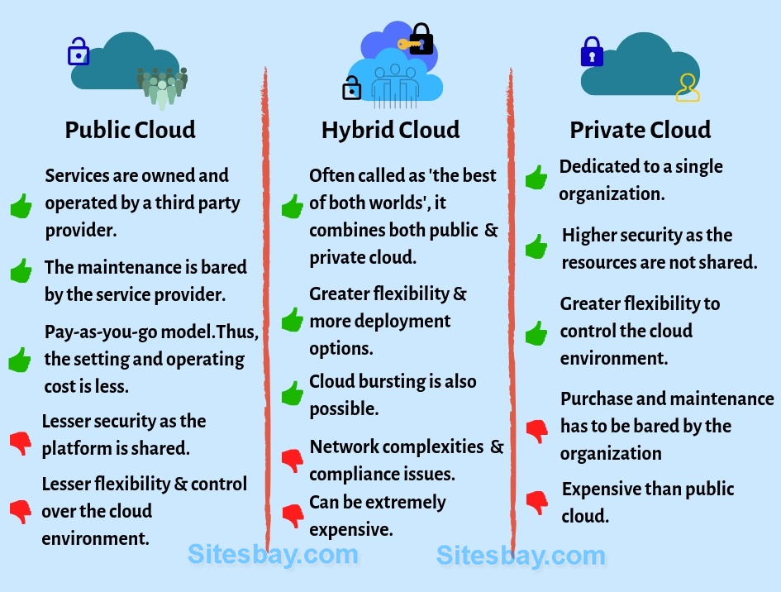

**3 type of services**

1. IAAS (Infra structure as a services)

2, PAAS (platform as a service)

3. SAAS (software as a services)

**Advantages of IAAS:-**

Shared infra structure

Pay as per use module

focused in use business

focused on scalability

**Dis-Advantages of IAAS :-**

Security

maintance and upgrade

**Advantages of PAAS:-**

simplified development

lower risk

scalability

**Disadvantages of PAAS:-**

Vendor locking and flexibility

Integrating with rest of the applications

**SAAS Advantages**

Reduced time to benefit

Scalable and Integration

trouble free and upgrading

Easy to use and perform proof of concept

**SAAS Disadvantages**

Insufficient Data security

Difficult

low performance

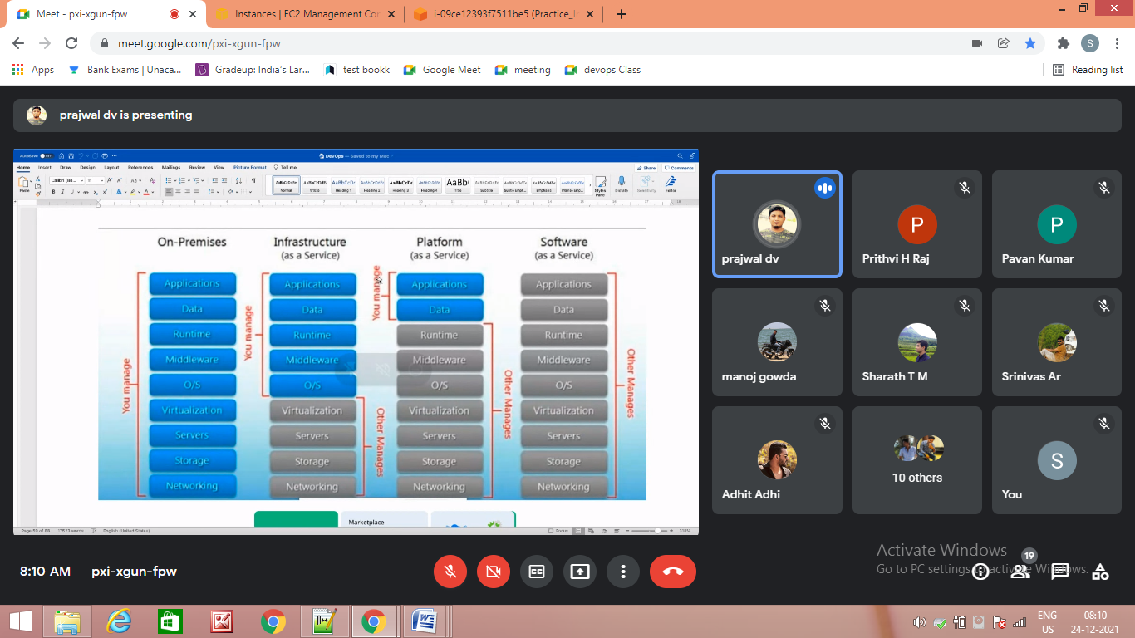

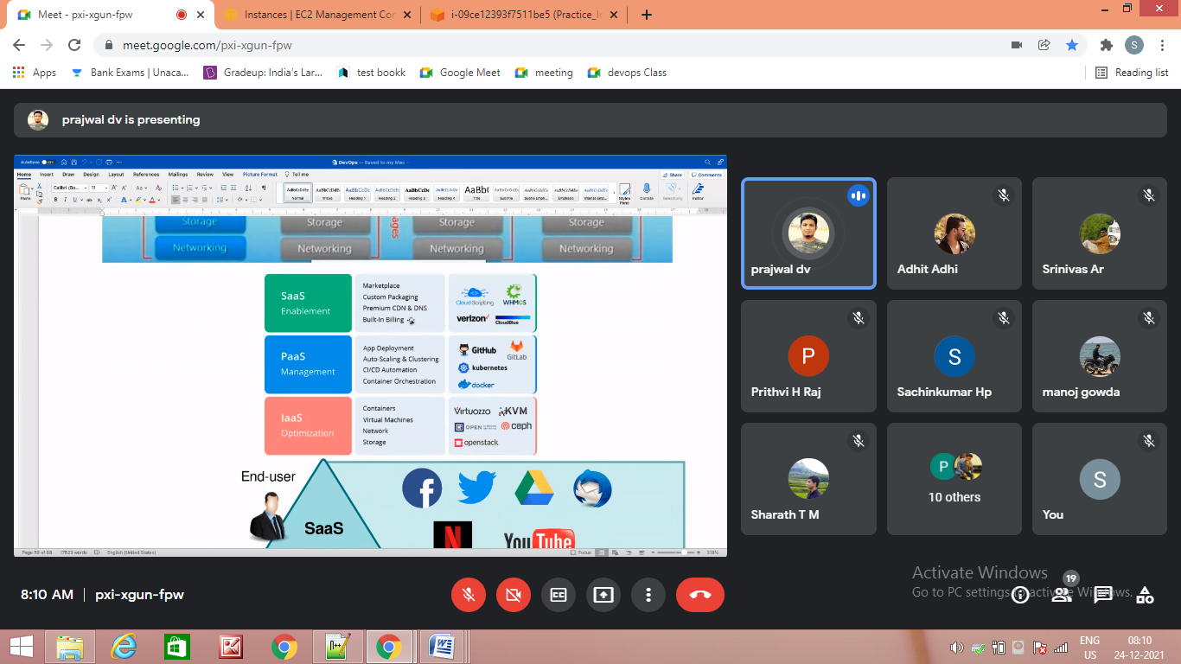

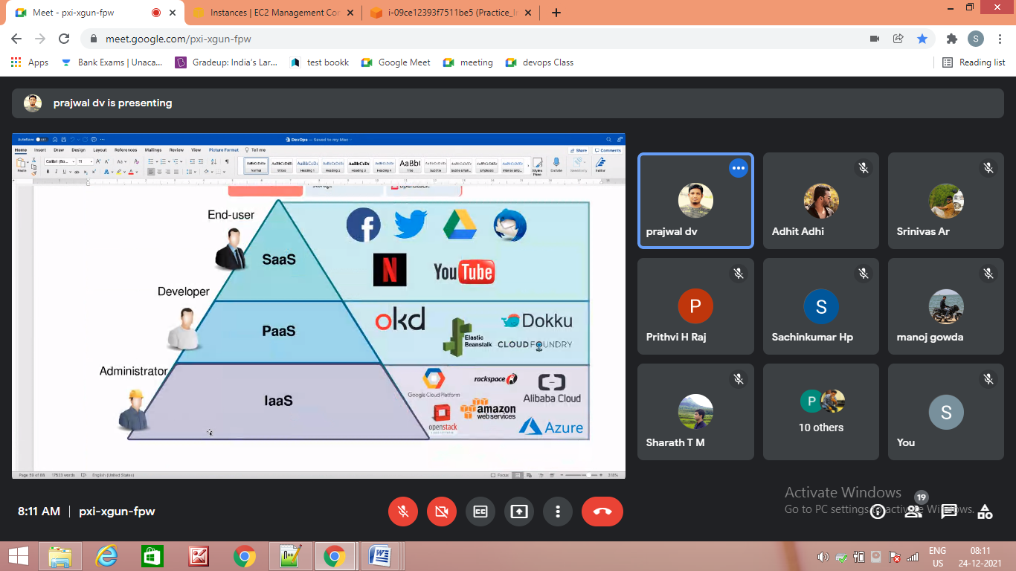

**Unix Architecture**

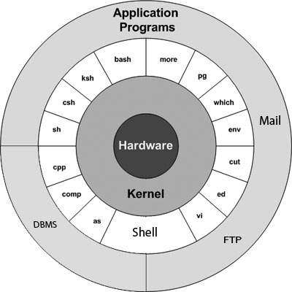

**CICD Pipeline**

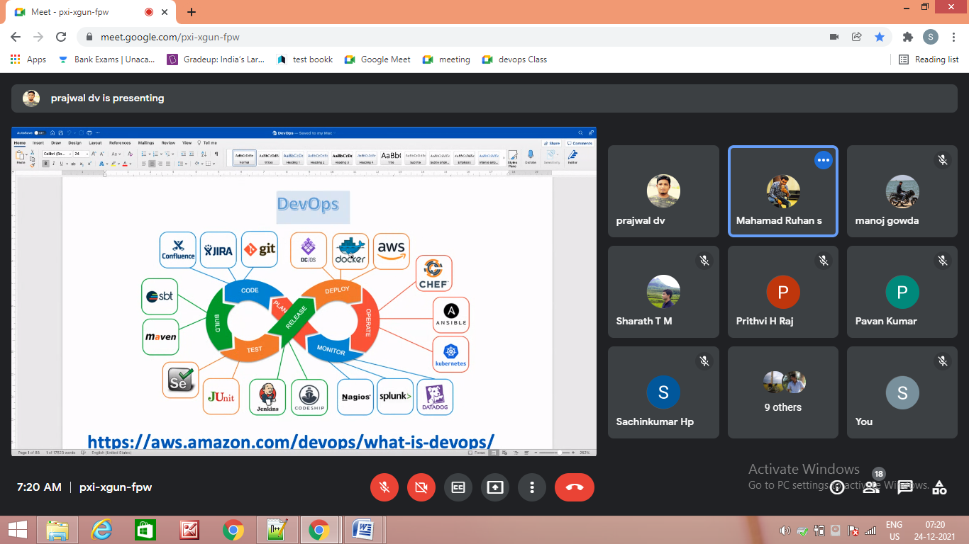

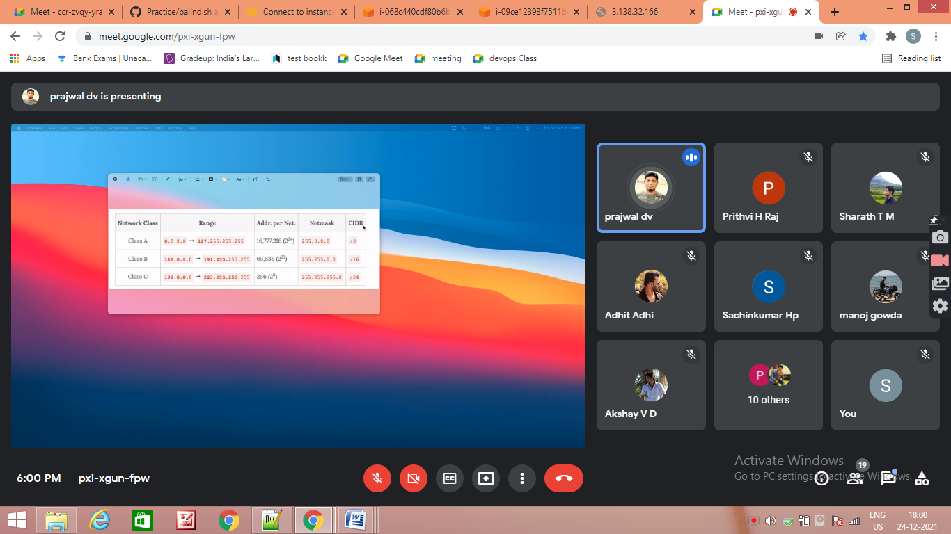

**Ip address:**

Class A : 1.X.X.X TO 126.X.X.X

Class B : 128.X.X.X TO 191.X.X.X

Class C: 192.X.X.X TO 223.X.X.X

Class D: 224.X.X.X TO 239.X.X.X

Class E: 240.X.X.X TO 254.X.X.X

127.0.0.0 is called loopback ip (it is reserved)

**Subnets Hosts Mask Subnet Bits Host Bits**

2 4,194,302 255.192.0.0 2 22

6 2,097,150 255.224.0.0 3 21

14 1,048,574 255.240.0.0 4 20

30 524,286 255.248.0.0 5 19

62 262,142 255.252.0.0 6 18

126 131,070 255.254.0.0 7 17

254 65,534 255.255.0.0 8 16

510 32,766 255.255.128.0 9 15

1,022 16,382 255.255.192.0 10 14

2,046 8,190 255.255.224.0 11 13

4,094 4,094 255.255.240.0 12 12

8,190 2,046 255.255.248.0 13 11

16,382 1,022 255.255.252.0 14 10

32,766 510 255.255.254.0 15 9

65,534 254 255.255.255.0 16 8

131,070 126 255.255.255.128 17 7

262,142 62 255.255.255.192 18 6

524,286 30 255.255.255.224 19 5

1,048,574 14 255.255.255.240 20 4

2,097,150 6 255.255.255.248 21 3

4,194,302 2 255.255.255.252 22 2

**Classless Inter-Domain Routing (CICD)**

is a method of assigning Internet Protocol (IP) addresses that improves the efficiency of address distribution and replaces the previous system based on Class A, Class B and Class C networks.

**What is VPC (virtual private cloud)?**

It is a virtual network dedicated to your AWS account, it logically isolates from other virtual networks in the AWS cloud, and where you can launch your AWS instance.

VPC consist of subnets, network gateway & Routing table.

**What is a subnet?**

Subnet is a logical subdivision of IP network. The practice of dividing a network into 2 or more networks is called sub netting.

**What is Route table?**

A set of rules called routes that are used to determine where network traffic is directed.

**What is Internet gateway?**

A gateway that you attach to your VPC to enable communication between resources in your VPC and the internet.

**What is NAT gateway?**

NAT Gateway is used to connect to the Internet from instances within a private subnet in the VPC.

Nat gateway will be created from Public subnet and attach to the private subnet.

**What is NACL (Network ACL)? Network Access Control Lists**

NACL are firewall at the subnet level.

You can use a network ACL to control the traffic to and from the subnet in which NAT gateway is located.

**What is VPC endpoint?**

It enables you to privately connect your VPC to supported AWS services and VPC endpoint services powered by private link without requiring an internet gateway, NAT device, VPN connection or AWS direct connection.

**Ex:-**Banking Project

**What is a security group?**

A security group acts as a virtual firewall for your instance to control inbound and outbound traffic.

When you launch an instance in a VPC, you can assign up to 5 security groups to the instance.

Security group act at instance level and not at subnet level.

**Difference between public subnet and private subnet**

**Public Subnet –** Users can access resources from the internet. Internet traffic is routed via internet gateway. Applications are stored in public subnet.

**Private Subnet -** Users cannot access resources from the internet. Internet traffic is routed via NAT gateway. Data is stored in private subnet (database, API calls, passwords)

**What is VPC peering connection?**

A VPC peering connection is a network connection between 2 VPC’S that enables you to route traffic between them using private IPV4 or IPV6 address.

Instances in either VPC can communicate with each other as if they are within the same network.

You can create a VPC peering connection between your own VPC or with a VPC in another AWS account.

**Limitations of VPC peering.**

* You cannot create a VPC peering connection between VPC’S that have matching or overlapping IPV4 CIDR blocks. Amazon always assigns a unique IPV6 CIDR block.
* You have a quota on the number of active and pending VPC peering connections that you can have per VPC.
* VPC peering does not support transitive peering relationships. In VPC peering connection, one VPC does not have access to any other VPC with which the peer VPC may be peered.

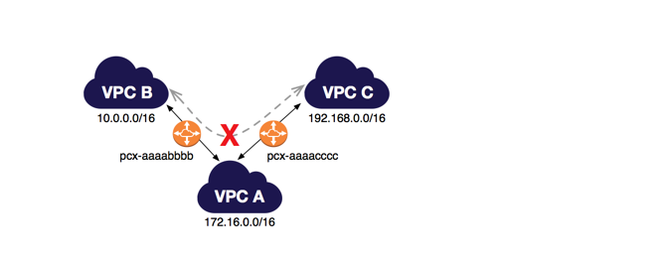

* Cannot have more than 1 VPC peering connection between the same 2 VPC at the same time.

**VPC Peering Use cases**

Your company has a VPC for the finance department, and another VPC for the accounting department. The finance department requires access to all resources that are in the accounting department, and the accounting department requires access to all resources in the finance department.

Your company has multiple IT departments, each with their own VPC. Some VPCs are located within the same AWS account, and others in a different AWS account. You want to peer together all VPCs to enable the IT departments to have full access to each others' resources.

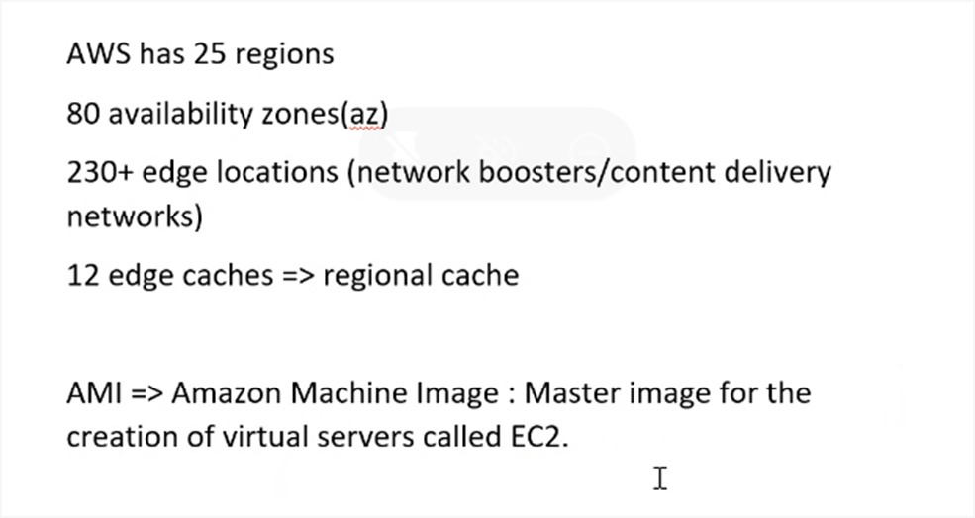

Both the Edge Locations (EL) and Availability Zones (AZ) are **AWS Data Centers**, but EL are primarily used for caching of the data to provide better user experience with low latency, the AZ are used for hosting servers, websites, applications, softwares, Big Data processing, analytics and a wide variety of use cases

**Region details**

**Region** US East N Virginia us-east-1

**AZ :-** us-east-1-a, us-east-1-b,

**Region** US East ohio us-east-2

**AZ :-** us-east-2-a, us-east-2-b, us-east-2-c

**Region** Asia pacific (mumbai) , ap-south-1

**AZ :-** ap-south-1-a, ap-south-1-b, ap-south-1-c

**EC2-instance classifications**

## AWS instance class.jpgSG and NACL.jpg

**Types of EC2 payment models:**

**1. On demand or capacity reservation:**

a. These instances work as pay as you go model.

b. Long time commitment is not required for this instance.

c. These are bit costlier

**2. Spot instances:**

a. These are called as bidding instances.

b. We can bid these instances as per the requirement.

**3. Dedicated hosts:**

a. Basically, dedicated instances are provided with the hardware configurations.

**4. Reserved instances:**

a. These are utilized for the longer time frame.

b. These would be having discounts in terms of pricing because of longer utilization time frame.

c. Will get to know platform, tenancy, instance type and payment options for reserved instances.

1. **EFS (Elastic File System):**  
   It is similar to shared disk, EFS is more used in case of sharing the disk space. EFS storage is used in cluster management in order to have availability.

**Eg** – Cassandra cluster, kubernetes, Machine learning and AWS lambda.  
Storage space sharing is possible in EFS.

**Advantages of EFS:**  
cost effective, Speed, Disk share.

1. **EBS (Elastic Block Storage):**  
   EBS provides simple , scalable, high available block storage. EBS can only attach to one EC2 system. It is block storage.Storage space sharing is not possible.

**Types of EBS -**i) Provisioned  
ii) General Purpose  
iii) Magnetic

**Important 3 models of EBS:**

1. Provision IOPS (64000)
2. General purpose (16000)
3. Magnetic (5000)

**Note: EBS can be attached to only one instance, EBS and Volume should be there in same region to avail the EBS**

**Benefits of EBS:**

1. SSD storage technology (solid-state drive)
2. Highly available, fast and scalable

**S3 (Simple Storage Service) :**  
It is basically a object storage. S3 cannot hold data, but it can store & hold data which are in form of objects. S3 is not region specific. We can host static website on S3.

Types of S3 bucket -   
 a) S3 Standard_ia  
 b) S3 Standard  
 c) S3 intelligent tiering  
 d) S3 Glacier  
 e) S3 Deep archive

**Key Features of S3:**

* 1. Versioning – AWS S3 is a means of keeping multiple variants of an object in same bucket, you can use the S3 versioning feature to preserve, retrieve and restore every version of every object stored in your bucket. Versioning enabled buckets can help you recover objects from accidental deletion or overwrite.
  2. Life cycle management.
  3. Encryption
  4. Multifactor authentication for object deletion.

**S3 bucket Security:**  
There are two types of bucket security:

* 1. Bucket Policies – Json based scripts which are embedded in IAM policies of AWS which can be utilized for S3 bucket security.
  2. Access control List.

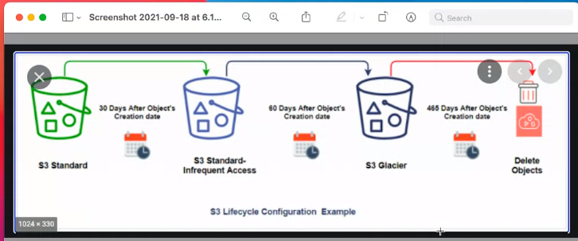

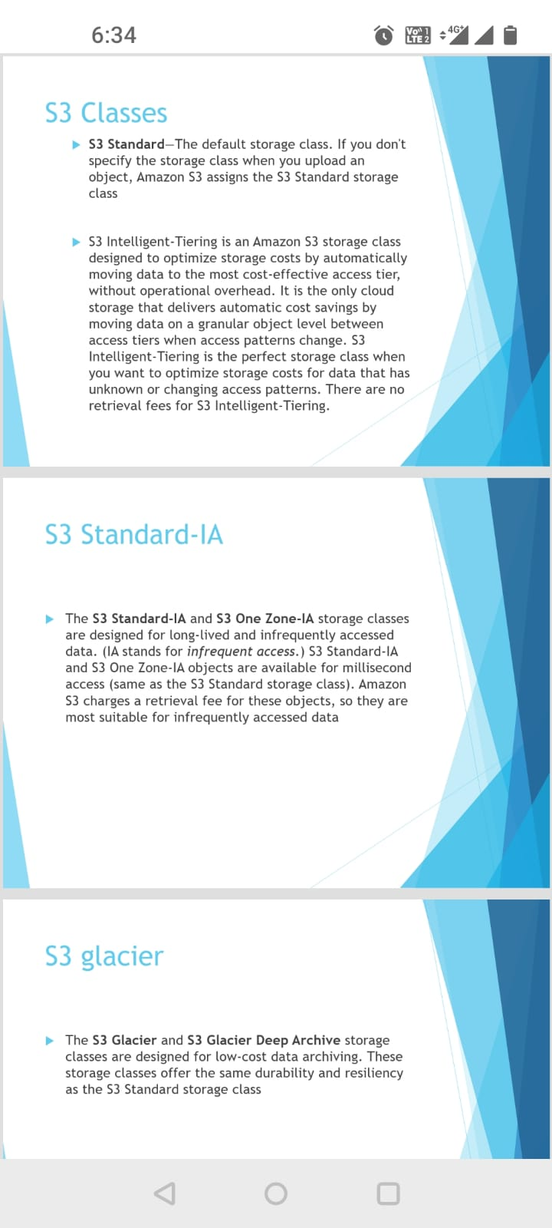

**S3 Storage class**

**S3 standard class :-** used for frequently ask, data majorly used in big data analysis , used in content distribution, cloud front

**S3 stander IA : -** Suitable for data less frequently accessed lower cost compare to s3 standard. majorly used for recovery and backup

**S3 intelligent tearing :-**  cost optimizing automatically moving objects

**Aws s3 Glacier:-**  low cost storage archiving and backup, we get retrieval options,

S3 Glacier is the lowest bucket.

**Deep archive**

**Maven and Ant and Gradel**

Ant and Maven both are build tools provided **by Apache**. The main purpose of these technologies is to ease the build process of a project.

